For a great Old Testament example of hesed, read and study the story of Ruth in the book of Ruth.
See especially Ruth 1:16-17, “But Ruth replied, “Don’t urge me to leave you or to turn back from you. Where you go I will go, and where you stay I will stay. Your people will be my people and your God my God. Where you die I will die, and there I will be buried. May the Lord deal with me, be it ever so severely, if even death separates you and me.”

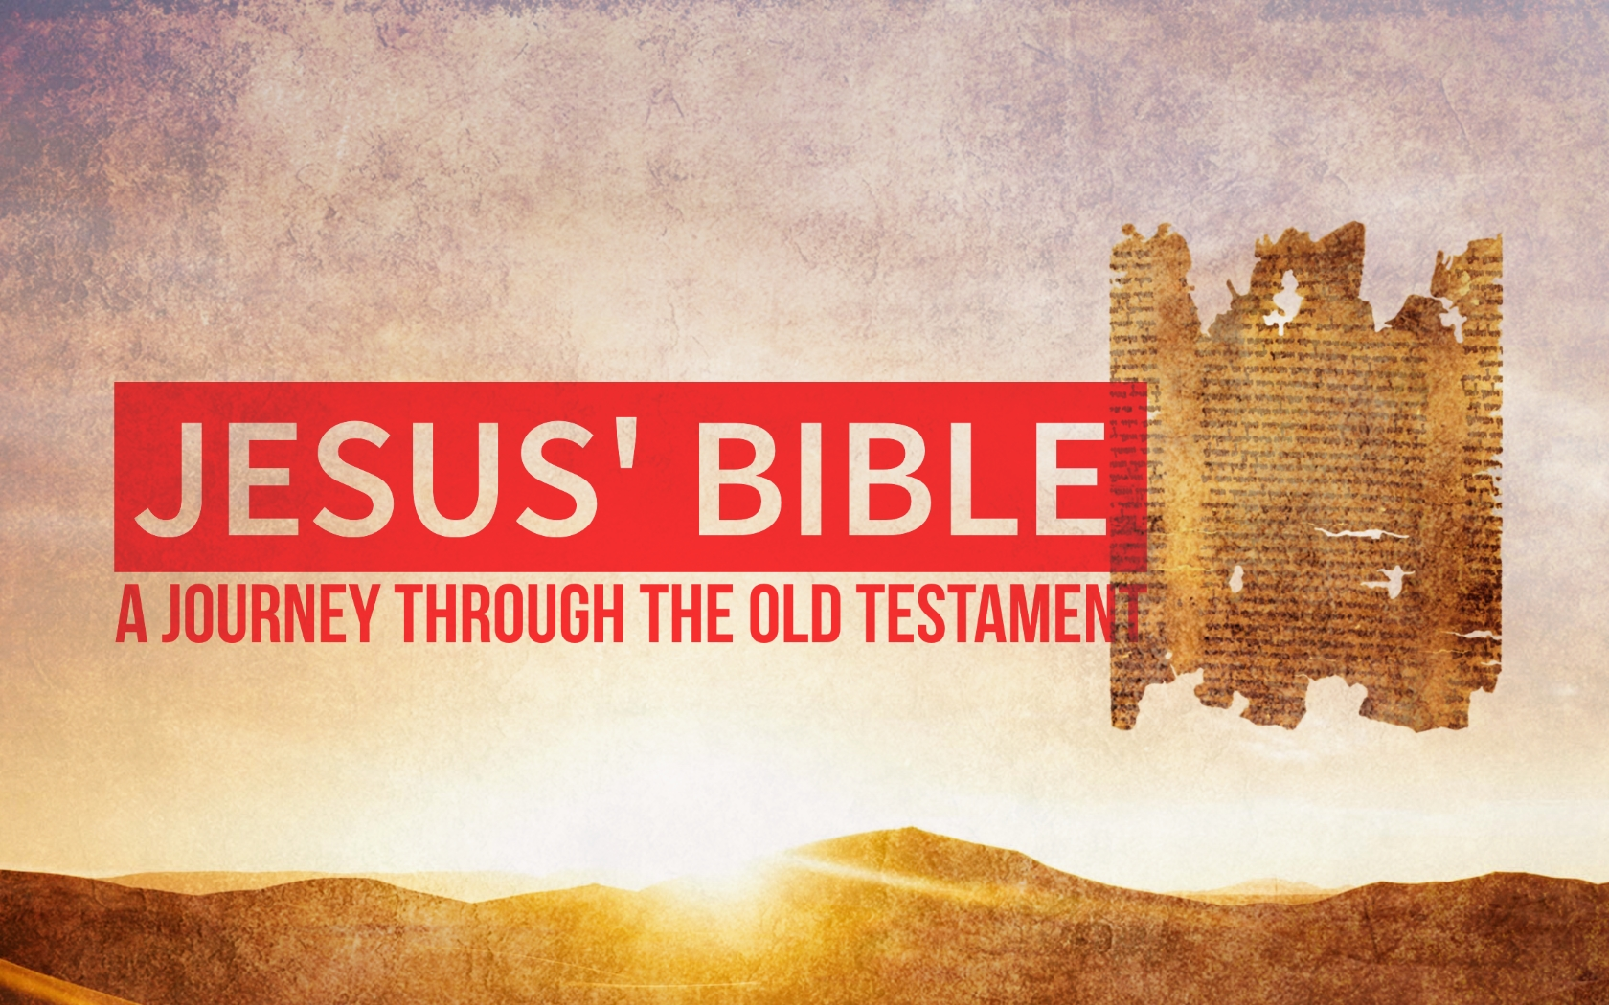

Jesus and the Law (part 2)
July 23rd, 2017

“You can’t fully understand Jesus if you don’t understand his Bible.”

Review:
- Christians have a complicated relationship with the Law.
- We follow some laws, but not others.
- Matthew 5:17-20: “Do not think that I have come to abolish the Law or the Prophets. I have not come to abolish, but to fulfill them.”

What is the Christian’s relationship with the Law?

The “Law” can refer to different things:
- The ______________ Old Testament.
- Only the _____________. (Genesis, Exodus, Leviticus, Numbers, Deuteronomy)
- Most often, the Law of _________________.
  - Sometimes including the _____________ law.

Why do some laws apply and not others?
The Law of Moses is like a ______________ law.
- It applied only to certain __________________.
- It might contain ____________________ laws.

The Law of Moses ______________ applied to Gentiles.
- Don’t try to prove the Bible says something is wrong by pointing to the Law of Moses.

How can we tell if a law is universal?
- If it was wrong _______________ the Law was given to Moses.
- If the _________ _________________ repeats the Law.

How is the Law still useful?
- It teaches us about God’s ___________________.
- It tells us our __________________ is our greatest witness.
- It creates a ____________ and _____________ society.
- It contains some universal ______________ principles. (It names sin.)
Reading the Law through the lens of Jesus:
- Moving from outward conformity to godly ___________________.
  - Murder/Anger (5:21-22)
  - Adultery/Lust (5:27-28)
  - Oaths/Truthfulness (5:33-37)

- From doing the least to going _______________.
  - Turn the other cheek (5:38-41)
  - Love your enemy (5:43-48)

- From generic love to “_____________.”
- The Greatest Commandments (Mt 22:34-40)

“It is a rugged commitment to be with and for others that leads to transformation.” –Scot McKnight

