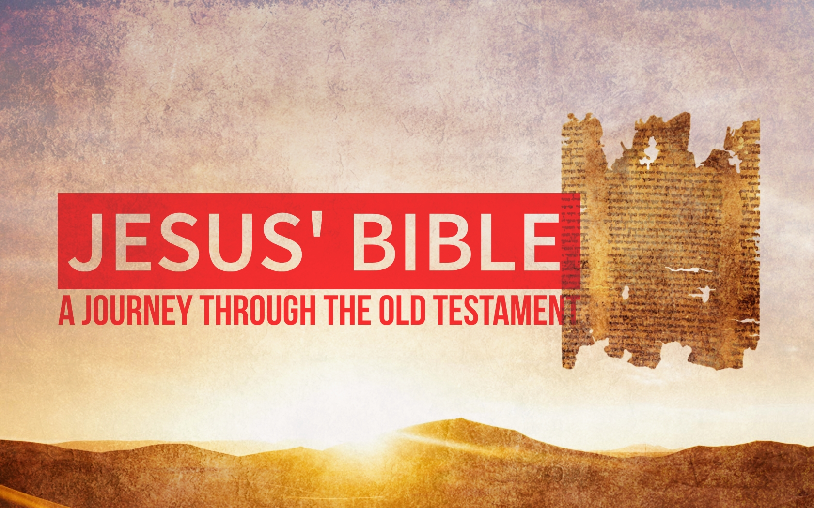

Good News! God Reigns!
July 30th, 2017

“You can’t fully understand Jesus if you don’t understand his Bible.”

The Psalms mirror the faith of ________________, and when we encounter them, we have the opportunity to catch a glimpse of how God’s chosen people interacted and perceived their relationship with the _____________. (Psalm 100 and 137)

Many scholars believe that the Psalms were not composed for private, but for _______________ worship.

The Psalms all have a common message—that God ______________!
The Messiah’s message was that the ________________of ___________ is at hand.

In the Old Testament, we often find the writers of the Psalms afflicted, oppressed, poor, needy, weak, meek, and persecuted. However, much like the Psalms, it is often these people whom Jesus pronounces ____________ or ________________.

The Sermon on the Mount (Matthew 5:1-12)
William Glasser’s Quality World contains what you ___________ ___________________ what you wish for, or what you had at one time…..

The problem people have with the sermon on the mount is that it ____________________ our Quality World.

If you set your mind on things above, your heart will align itself with the things which are upright, wise, and ___________________ sound.

We are always allowing something to take place in our ________________, always presenting our Quality World in some manner.

Scholars believe Jesus had Psalms _______ and _______ in mind when he taught the Sermon on the Mount.

Psalm 73 causes us to consider God’s _____________________.
- God is Sovereign because he will never ________________ you.

- God is sovereign because despite what the wicked world may conspire against you, it does not change the fact that Jesus has paid the price on the cross for your ___________ and God reigns victorious through his obedient faithfulness unto death.

- God is sovereign because today in this very moment he is ___________ you in your struggle.

