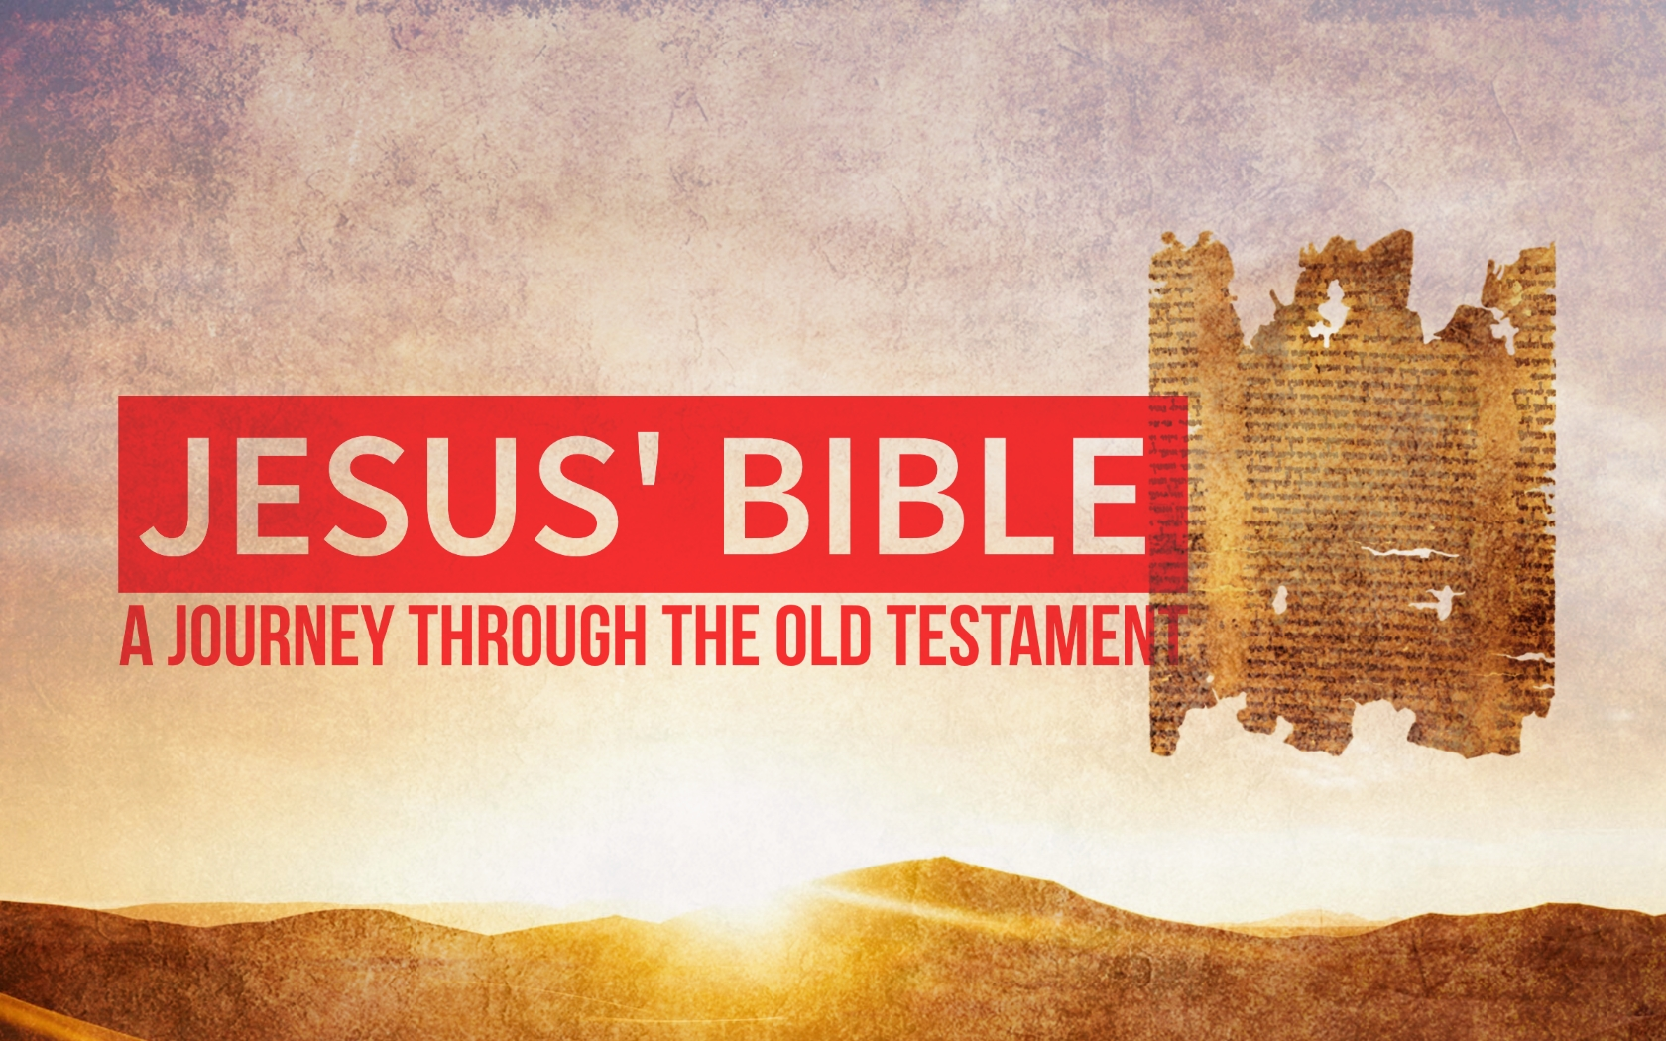

The Lord’s Supper
July 9th, 2017

The Lord’s Supper is a strange ritual to the modern mind:
- We eat the ____________ and drink the ___________ of Jesus.

- It is a ________________ ritual in an individualistic world.

- Our society is doing away with all ______________.

Most people think rituals are a symbolic act that proves our ________________ to a person, organization or God.

Rituals are everyday actions that help us __________ what we couldn’t ____________ before. –Dru Johnson
How we learn:
- Trust an ____________________.

- ________ what the authority says.

Scripture: Luke 22:7-20

Our typical understanding of The Lord’s Supper: We remind ourselves of the price Jesus paid so our ____________ can be forgiven and we can be with God in heaven someday.

The Lord’s Supper takes on a much richer meaning when we understand Jesus instituted the Lord’s Supper as the new __________________.

Passover:
One of the main feasts _____________________ (not suggested) by God in the OT. (Exodus 12:14)

Has been celebrated for almost __________ years!

It re-enacts the Exodus.
- Israel had been slaves in __________ for 430 years.
- God called Moses to tell Pharaoh to let them go. (Pharaoh resisted)
- God sent ten plagues to convince him.
- The last was the angel of death that took the first-born son…

…unless the family took a lamb without ________________ and spread its blood on the door posts of the house.

The angel would “___________ ___________” the house.

How Passover Shaped Israel:
- It reminded them they were once slaves in _____________.

- It reminded them and future generations that __________ freed them from slavery. (Exodus 10:2)

- It __________________ their identity as God’s people.

- It taught them to __________ and ____________ the God who saves and look forward to the day of salvation.

How the Lord’s Supper Shapes Us:

- It reminds us that we were once slaves to __________.

- It reminds us that _____________ freed us from slavery. (Rom 6:6)

- It reminds us of our identity as the ____________ of ____________.

- It reminds us that we will one day partake in the great ____________ in the Kingdom of God. (1 Cor 11:26)

