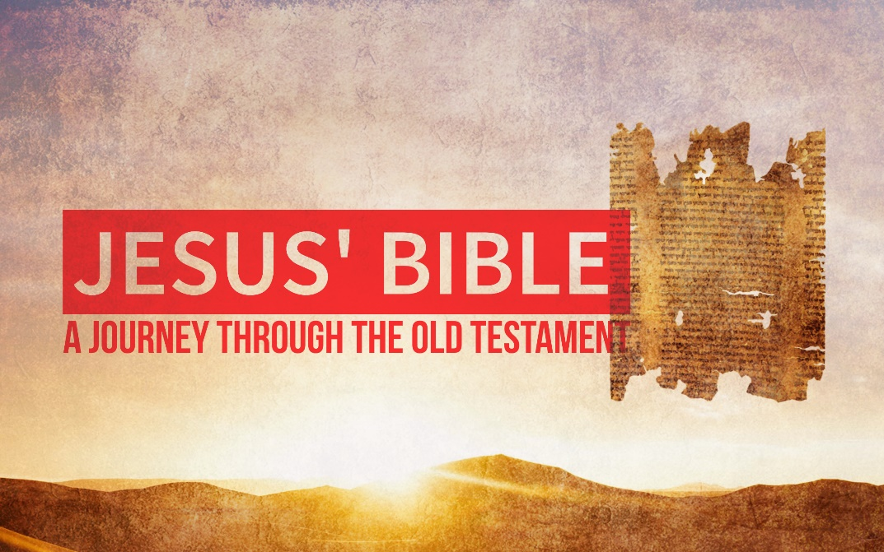

**Jesus’ Bible:   
Mercy vs. Sacrifice**  
Matthew 9:9-13

Jesus

* Studied Old Testament as a ___________
* Studied the Old Testament at the ___________
* Studied the Old Testament at home with ___________
* _____________ the Old Testament as a child
* ____________ the Old Testament skillfully with religious leaders
* Affirmed the ____________ of many Old Testament people
* Treated the Old Testament as ______________
* Found large significance in even ____________ words in the OT

The Old Testament ____________ to Jesus and it should ____________ to us.

In Matthew 9:9-13 Jesus quotes Hosea 6:6

Sacrifice

* ______________ by God
* Valued and ______________ by Jesus
* _________________ in the Scriptures
* Not the _______________ of mercy
* A _________________ to mercy

1. **God desires to show _______________**

The Pharisees have focused on the ___________ but forgot the ______________.

God’s purpose for ritual and religion isn’t to ________________ but rather to be merciful.

1. **God’s mercy is not a ______________ to sin**

*v. 12 “It is not the healthy who need a doctor but the sick.”*

It’s the mercy of God that brings the sinner to the table to be __________________.

It’s the _________________ doctor who does not want to cure the sick.

1. **God desires for you to show _______________ mercy**

**23**“Woe to you, teachers of the law and Pharisees, you hypocrites! You give a tenth of your spices—mint, dill and cumin. But you have neglected the more important matters of the law—justice, mercy and faithfulness. You should have practiced the latter, without neglecting the former.

With all rules and no mercy you’re just as worse off as the person with no rules and all mercy.

“It’s the mercy of God that brings the sinner to the table to be transformed.”

**Questions for Reflection:**

1. Is it hard to imagine that God’s primary goal for religion and rituals and rules is for our benefit? That we would receive mercy?
2. The mercy of God isn’t a license to sin but rather, it’s an expectation that we would be more and more like God. Are there parts of your life that are challenged by this fact?
3. Are you guilty of straining gnats while swallowing camels? Do you commonly focus on God’s rules while forgetting His heart?