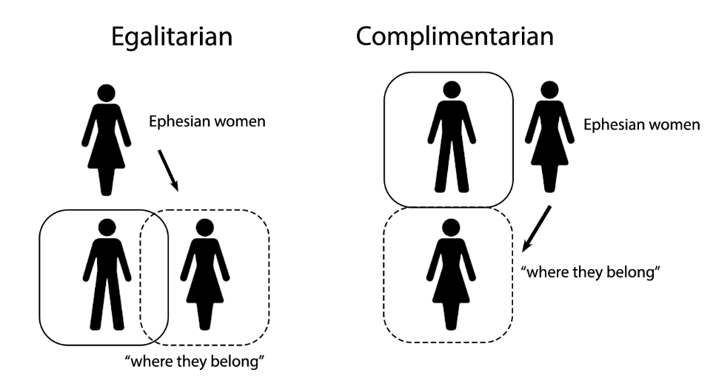

“Women will be saved through childbearing…” (vs 15)
Saved in the Bible isn’t always _____________ salvation.
Paul says, “You don’t need _______________ protection.”

Takeaways:
- What have you had to give up because of your faith in Christ? What do you gain in its place?
- God has created the Church to be a community where distinctions of class, ethnicity and gender are irrelevant.

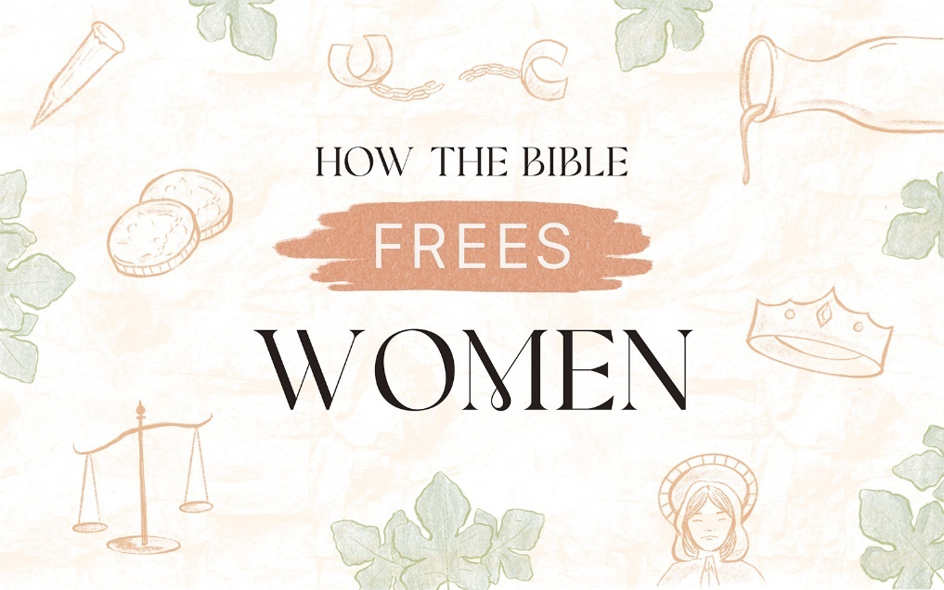

The “Proof” Texts

Recap:
- God’s original intent for men and women was equal partnership.
- Patriarchy is sin’s corruption of God’s good order.
- Jesus began to undo the curse by including women and Paul continued that work.

“In Christ, there is no Jew nor Gentile, Slave or free, male or female, for you are all one in Christ Jesus!”
Galatians 3:28

Rule #1 in Biblical interpretation: _______________ is everything!

______________ was THE god of the Ephesians.

- She watched her mother give birth to her twin, Apollo (for _________ days!)
- Committed herself to _______________.
- Portrayed as a great hunter who could kill with _______________ arrows.
- Beautiful and adorned with braids and ___________ in her hair.
- Dedicated herself to be a ______________ for women who called on her.

The Cult:
- Female _________________
- Associated with _____________
- Highly prized _____________
- Promised safety in _______________

Scripture: 1 Timothy 2
Paul’s letter to Timothy had two purposes:
- To counter ____________ teaching.
- To instruct Timothy in how to facilitate unity and _______________ in the church.

“Lift up holy hands without disputing or arguing.” (vs 8)
Paul wanted to put everyone on ____________ footing in the church. (vs 8)

“women…dress modestly” (vs 9)
How you dressed was a sign of your ___________ ___________.

Paul wanted modest dress so there would be no class distinctions in the church.

“A woman should learn…” (vs 11)
“…but she is to do it in quietness and submission…”

“I am not permitting a woman to assume authority…”
Normal: exousia = “proper authority”
Paul uses: authentēs = “to dominate or snatch authority”

“for Adam was formed first, then Eve…” (vs 13-14)

Traditional: Women are more easily _______________ than men.

Paul was countering a _____________ story with a __________ story.

