**Questions for Reflection:**

1. What stood out to you about the message?
2. Do you feel you are strategic about your money? Why or why not?
3. Are you more strategic about your personal financial goals or God’s goals?
4. What decisions might you make differently if you remember that everything belongs to God?
5. What is one way you can enjoy money by blessing others?

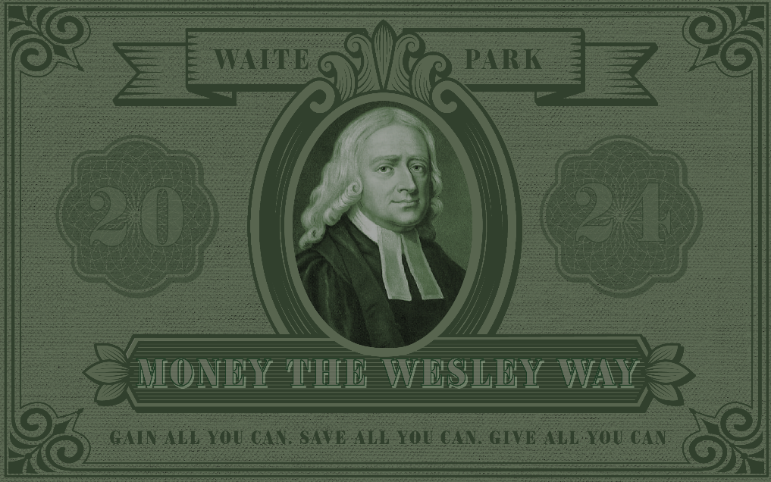

**Money True or False**

­­­­­­__________________: From birth, we are discipled by the world to think in financial terms.

Yet we are often unaware of what ______ __________ says about money.

**Scripture: Luke 16:1-13**

The point: the people of the world are more strategic about using money to achieve ________________ goals than believers are about achieving ____________ goals.

When we ARE strategic, we focus on what the world says is ________________.

**The Wesley way:** ___________ and you can; ____________ all you can; ______________ all you can.

**Money True or False:**

**#1: Money is a Blessing T F**

**Answer: _______________**

Scripture: 1 Timothy 6:9

**#2: Money is the Root of all Evil T F**

**Answer: _______________**

Scripture: 1 Timothy 6:9-10

The problem is the __________ of money!

* Money gives us the ability to ______________ from each other.
* Money allows us to _______________ that we are self-made and self-sustaining.

**#3: My money belongs to me. T F**

**Answer: _________________**

Scripture: Psalm 24:1

I am God’s __________ ________________.

**#4: God doesn’t want me to enjoy what I have. T F**

**Answer: _____________**

Scripture: 1 Timothy 6:17

* Build _______________ into your budget
* ____________ others is enjoyable. Factor it into financial decision-making.
* Use money and possessions to bring people ______________ rather than to _______________.