**Questions for Reflection or Discussion:**

1. What stood out to you most about the message?
2. Why is self-control the key to true freedom? Can you think of examples?
3. Which ingredients of a self-controlled life are most important for you? Why?
4. Take the time to do the personal inventory. Share with the group.

**Personal Inventory**

1. What vision of your future self do you believe God has for you?
2. What are two or three areas of my life that I need to build self-control in order to become what God wants for me?
3. How will I do this?
   * What habits will I start?
   * What hard and fast rules do I need to make?
   * What is the greater good? (When I look back at the end of my life, what do I want to be true about me?)

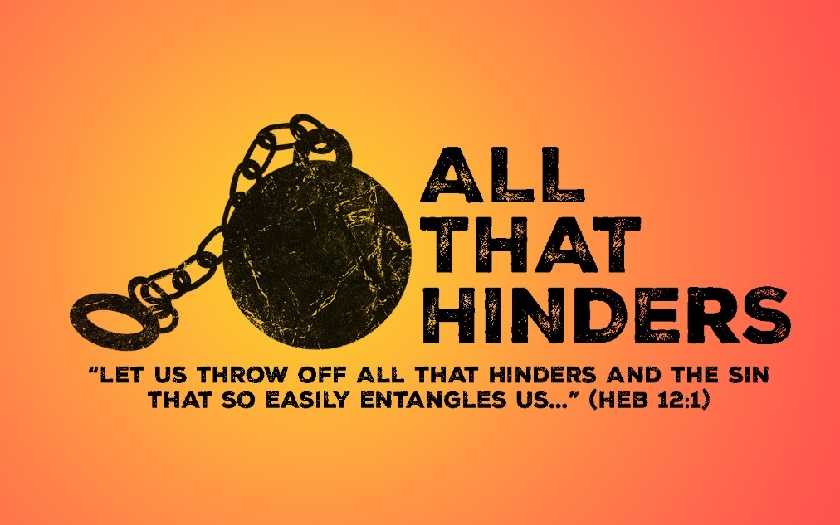

**Self-Indulgence**

Self-indulgence: an excessive or unrestrained gratification of one's own appetites, desires, or whims.

Our world believes indulging our every ________________ will make us happy.

**Two Kinds of Freedom**

“Freedom _____________”

“Freedom ________”

If we want to be truly free, we must replace self-indulgence with __________-_______________.

**Scripture: Titus 2:1-14**

1. **Paul begins with _________________. (vs 11)**

“Grace is not opposed to effort…” Dallas Willard

1. **Grace teaches us to say ______ to ungodliness and __________ to self-control. (vs 12)**
2. **The purpose of self-control is to lead a ________-________________ life. (vs 14)**

Self-control is the key that unlocks all kinds of other _______________.

**We need self-control with:**

* Eating and ___________________.
* ____________
* How we spend our _____________
* Social ___________________

We gain self-control by cultivating a ___________-_______________ life.

**Ingredients of a Self-Controlled Life**

1. **Keep the __________ in mind.**

**Two Questions:**

* “What does God want to be true of me at the end of my life?”
* “Does the path I’m on lead me there?”

1. **Embrace the power of _______________.**
2. **Think _______________, not ____________________.**

* ____________ habits.
* Make some hard and fast ____________.

1. **Develop a ____________ orientation.**

“His mercies are new every morning.” (Lamentations 3:23)

Think _________________, not __________________.