More Stories of Women to Explore:
- Hagar - Genesis 16:13
- Shiphrah and Puah - Exodus 1:15:21
- Deborah - Judges 5:31
- Ruth - Ruth
- Hannah - 1 Samuel 1:1-20
- Abigail - 1 Samuel 25
- Huldah - 2 Kings 22
- Esther - Esther
- Mary - Luke 1-2; Matthew 13:55; John 19:25-27; Acts 1:12-14, 2:1-4
- Susanna and Joanna - Luke 8:1-3
- Mary, the sister of Martha and Lazarus - Luke 10:38-42
- Mary Magdalene - Luke 8:1-3, John 20:1-18
- Lydia - Acts 16:11-15
- Nympha - Colossians 4:15-16

Recommended Reading
- Tell Her Story by Nijay Gupta
- Extraordinary Women of Christian History by Ruth Tucker
- Celebrate Our Daughters: 150 Years of Women in Wesleyan Ministry by Maxine L. Haines and Lee M. Haines

Recommended Resources for Kids
- She Believed: 12 Stories of Courageous Women of Faith Who Changed the World by Jean Fischer
- Called and Courageous Girls series by Rachel Spier Weaver and Anna Haggard
  - A Fearless Leader: A Bible Story About Deborah
  - A Brave Big Sister: A Bible Story About Miriam
  - An Extraordinary Teacher: A Bible Story About Priscilla
  - An Unexpected Hero: A Bible Story About Rahab
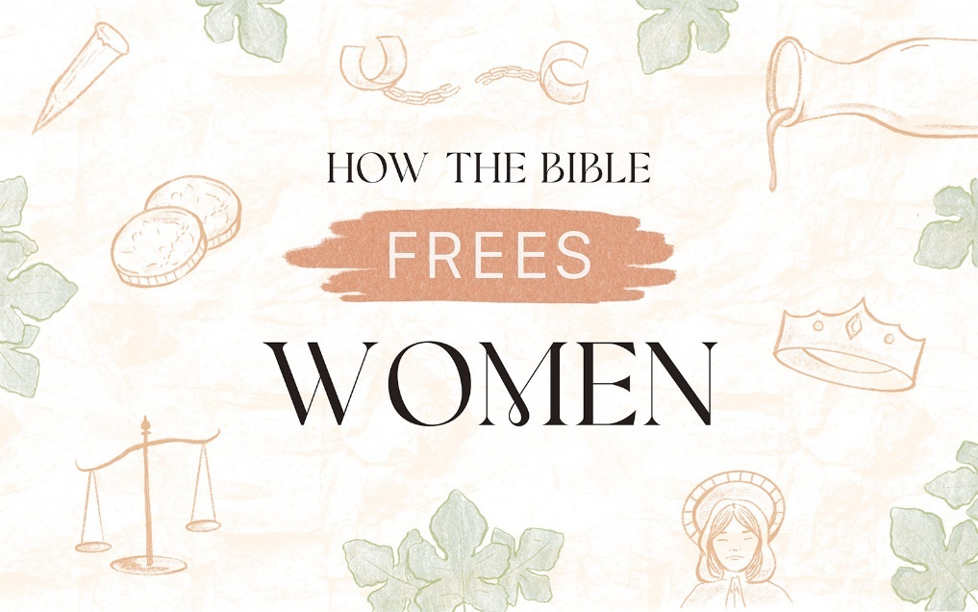

Tell Her Story

Recap:
- God’s original intent for men and women was equal partnership.
- Patriarchy is sin’s corruption of God’s good order.
- Jesus began to undo the curse by including women and Paul continued that work.
- When we understand the context of a passage of scripture, we can find greater clarity on how it should be interpreted. For example, the context of Ephesian culture helped us in better understanding 1 Timothy 2.
- Women have been and continue to be called, gifted, and anointed to serve the Kingdom.

Paul has a social agenda built into his greetings in Romans 16.
He mentions…
- ___________ and ___________ (e.g., Andronicus and Junia, Urbanus and Epaenetus)
- Those who were likely ___________ (e.g., Ampliatus, Urbanus, and Stachys)
- ___________ and ___________

“In Christ, there is no Jew nor Gentile, Slave or free, male or female, for you are all one in Christ Jesus!”
Galatians 3:28

Kopiaō
- Translated as “hard worker”
- Implies honorable _______________ for the sake of the Gospel or the Christian community, and it connotes _______________
- A word Paul uses to describe his own labor in ministry (Colossians 1:28-29, 1 Timothy 4:10)

Phoebe
- One of the first _________________ of the book of Romans
- Diakonos
  - Refers broadly to _________________
  - Used to refer to _______ and _________________
  - No single English translation that perfectly captures the meaning
  - New Testament scholar Nijay Gupta suggests the translation “_________________.”
Priscilla
- Acts 18
  - She and Aquila were _________________ like Paul.
  - Traveled with Paul to _________________
  - Invited _________________ to their home to teach him about baptism
- Those writing at the time of Paul and Luke tended to give _________________ through the order in which names were mentioned.

Junia
- Up until about 50 years ago, virtually all translations of the Bible translated her name as _________________ under the presumption that she was _____ _________.
- Junia is a widely attested name in _________________ _________________. There is no evidence of the name Junias ever existing.
- Apostolos: Usually implies carrying the _________________ to the world, much in the same way that Paul and Peter did in the book of Acts
- Junia was _________________.

